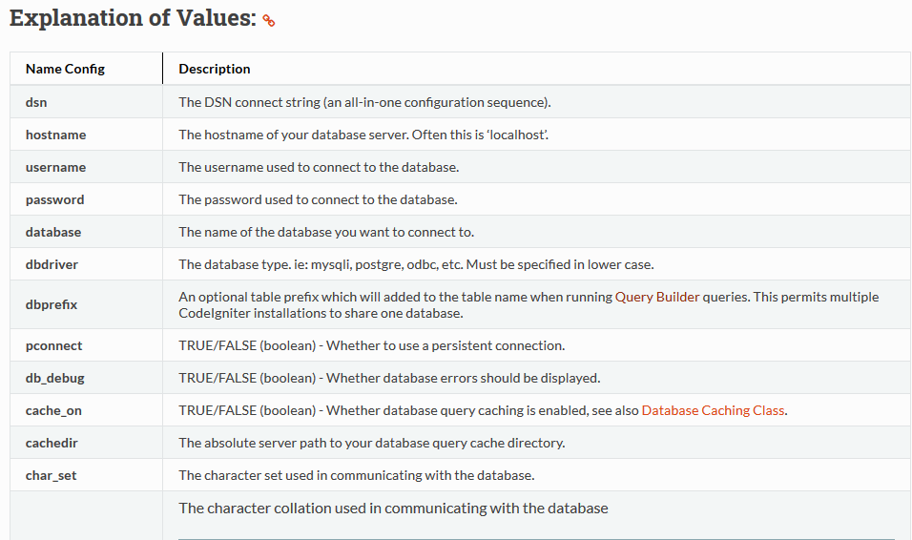

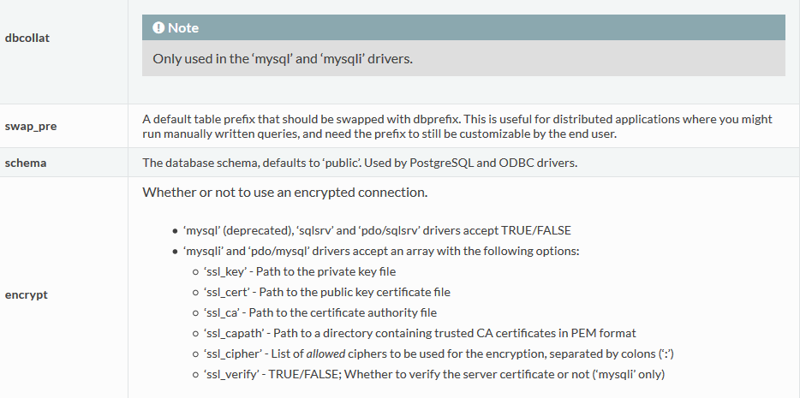

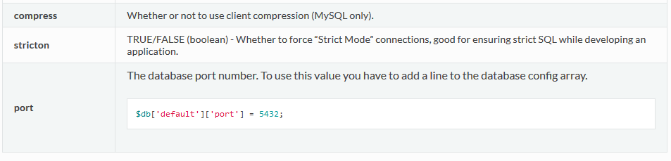

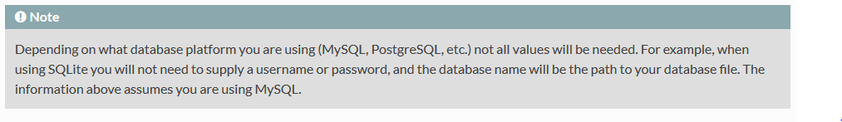

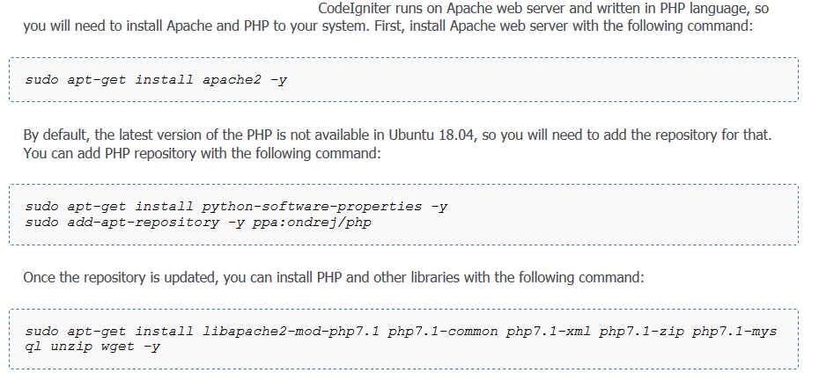

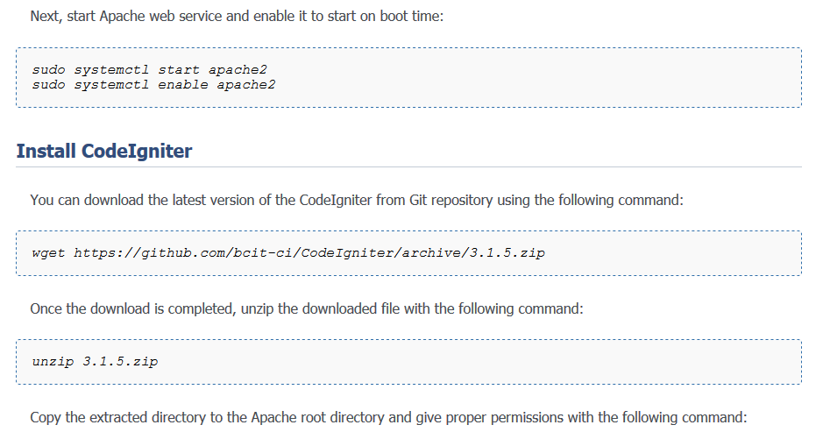

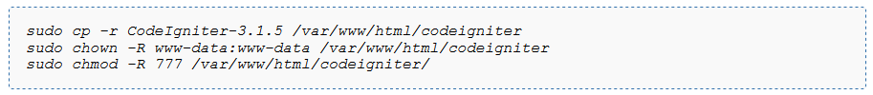

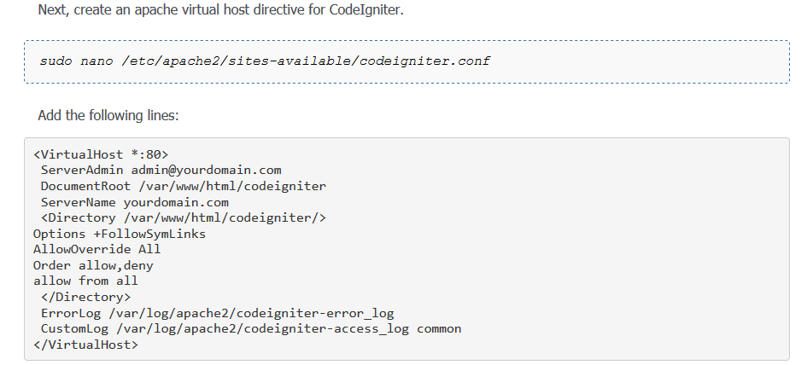

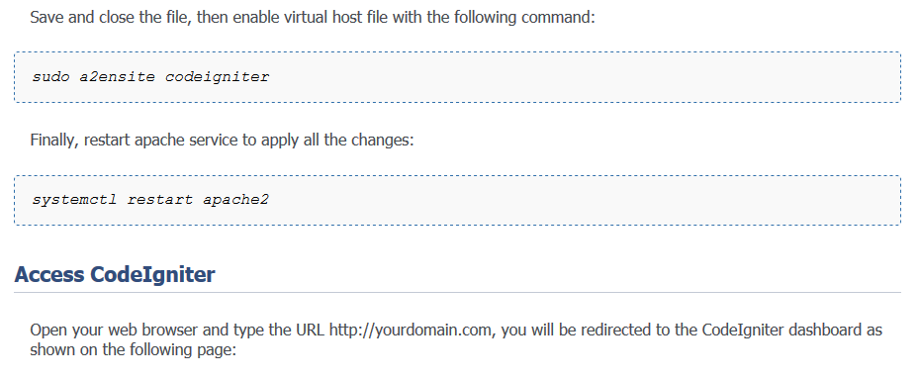

[www.dititalocean.com](http://www.dititalocean.com) *// how to ubuntu webserver*

1. Hostname : http:// ims.ju.edu.et
2. Server IP address: 10.142.0.0
3. Server password : Kf(?N1r //ims2020
4. DB Password: ok
5. serverAdmin: admin@ims.ju.edu.et

* cd /var/www/html
* wget <http://github.com/bcit-ci/CodeIgniter/Archive/3.0.6.zip>
* unzip 3.0.6.zip
* mv CodeIgniter-3.0.6 codeigniter
* mv /var/www/html/ codeigniter
* service apache2 restart && service apache2 status